This policy was reviewed by Australasian Society of Clinical Immunology and Allergy, Allergy & Anaphylaxis Australia Inc. For more information visit https://www.nationalallergystrategy.org.au/

Purpose
This policy provides guidelines Barry Rd Pre School to:
- minimise the risk of an allergic reaction including anaphylaxis occurring while children are in the care of Barry Rd Pre School
- ensure that service staff respond appropriately to allergic reactions including anaphylaxis by following the child’s ASCIA Action Plan for Anaphylaxis and ASCIA Action Plan for Allergic Reactions
- raise awareness of allergies and anaphylaxis and appropriate management amongst all at the service through education and policy implementation.
- working with parents/guardians of children with either an ASCIA Action Plan for Anaphylaxis or ASCIA Action Plan for Allergic Reactions in understanding risks and identifying and implementing appropriate risk minimisation strategies and communication plan to support the child and help keep them safe.

This policy should be read in conjunction with the Dealing with Medical Conditions Policy and Incident, Injury, Trauma and Illness Policy.

Policy Statement

Values

Barry Rd Pre School believes that the safety and wellbeing of children who have allergic reactions and/or are at risk of anaphylaxis is a whole-of-community responsibility, and is committed to:
- ensuring that every reasonable precaution is taken to protect children harm and from any hazard likely to cause injury
- providing a safe and healthy environment in which children at risk of anaphylaxis can participate fully in all aspects of the program
- raising awareness amongst families, staff, children and others attending the service about allergies and anaphylaxis
- actively involving the parents/guardians of each child at risk of anaphylaxis in assessing risks, and in developing appropriate risk minimisation and risk management strategies for their child
- ensuring all staff members and other adults at the service have adequate knowledge of allergies, anaphylaxis and emergency procedures
- facilitating communication to ensure the safety and wellbeing of children at risk of anaphylaxis.

Scope
This policy applies to the approved provider, persons with management or control, nominated supervisor, persons in day-to-day charge, early childhood teachers [ECT], educators, staff, students, volunteers, parents/guardians, children, and others attending the programs and activities of Barry Rd Pre School, including during offsite excursions and activities.
This policy will apply regardless of whether a child diagnosed by a registered medical practitioner as being at risk of anaphylaxis is enrolled at the service.

Responsibilities | Approved provider and persons with management or control | Nominated supervisor and persons in day-to-day charge | Early childhood teacher, educators and all other staff | Parents/guardians | Contractors, volunteers and students
R indicates legislation requirement, and should not be deleted
Ensuring that an anaphylaxis policy, which meets legislative requirements (Regulation 90) and includes a medical management plan (refer to Definitions) a risk minimisation plan(refer to Definitions) (refer to Attachment 3) and a communication plan (refer to Definitions), is developed and displayed at the service, and reviewed annually | R | √
Providing approved anaphylaxis management training (refer to Sources) to staff as required under the National Regulations | R | √
Ensuring that at least one ECT/educator with current (within the previous 3 years) approved anaphylaxis management training (refer to Definitions) is in attendance and immediately available at all times the service is in operation (Regulations 136, 137)  Note: this is a minimum requirement, ELAA recommends that ALL educators have current approved first aid qualifications, anaphylaxis management training and asthma management training. | R | √ | √
Ensuring that all ECT/educators approved first aid qualifications, anaphylaxis management training (refer to Sources) and emergency asthma management training are current (within the previous 3 years), meet the requirements of the National Act (Section 169(4)) and National Regulations (Regulation 137), and are approved by ACECQA (refer to Sources) | R | √ | √
Providing opportunities for ECT/Educators to undertake food allergen management training (refer to Sources) | √ | √ | √
Develop an anaphylaxis emergency response plan which follows the ASCIA Action Plan (refer to Attachment 4) and identifies staff roles and responsibilities in an anaphylaxis emergency. Emergency response plans should be practised at least once a year. Separate emergency response plans must be developed for any off-site activities. | √ | √ | √ |  | √
Ensuring ECT/educators and staff are aware of the procedures for first aid treatment for anaphylaxis (refer to Attachment 4) | R | √ | √
Ensuring all staff, parents/guardians, contractors, volunteers and students are provided with and have read the Anaphylaxis and Allergic Reactions Policy and the Dealing with Medical Conditions Policy (Regulation 91) | R | √
Ensuring that staff undertake ASCIA anaphylaxis refresher e-training (refer to Sources) practice administration of treatment for anaphylaxis using an adrenaline injector trainer (refer to Definitions) twice a year, and that participation is documented on the staff record | R | √ | √
Ensuring the details of approved anaphylaxis management training (refer to Definitions) are included on the staff record (refer to Definitions), including details of training in the use of an adrenaline injectors (refer to Definitions) (Regulations 145,146, 147) | R | √ | √
Ensuring that parents/guardians or a person authorised in the enrolment record provide written consent to the medical treatment or ambulance transportation of a child in the event of an emergency (Regulation 161), and that this authorisation is kept in the enrolment record for each child | R | √ |  | √
Ensuring that parents/guardians or a person authorised in the child’s enrolment record provide written authorisation for excursions outside the service premises (Regulation 102) (refer to Excursions and Service Events Policy) | R | √ | √ | √
Identifying children at risk of anaphylaxis during the enrolment process and informing staff | √ | √ | √
In the case of a child having their first anaphylaxis whilst at the service, the general use adrenaline injector should be given to the child immediately, and an ambulance called. If the general use adrenaline injector is not available, staff will follow the ASCIA First Aid Plan (refer to Attachment 4) including calling an ambulance | √ | √ | √ |  | √
Following appropriate reporting procedures set out in the Incident, Injury, Trauma and Illness Policy in the event that a child is ill or is involved in a medical emergency or an incident at the service that results in injury or trauma (Regulation 87) | R | √ | √ |  | √
In addition to the above, services where a child diagnosed as at risk of anaphylaxis is enrolled, also responsible for:
Displaying a notice prominently at the service stating that a child diagnosed as at risk of anaphylaxis is being cared for and/or educated by the service (Regulation 173(2)(f)) | R | √
Ensuring the enrolment checklist for children diagnosed as at risk of anaphylaxis (refer to Attachment 2) is completed | R | √
Ensuring an ASCIA Action Plan for Anaphylaxis/ ASCIA Action Plan for Allergic Reactions completed by the child’s doctor or nurse practitioner is provided by the parents are included in the child’s individual anaphylaxis health care plan | R | √ | √
Ensuring risk management plan (refer to Definitions) (refer to Attachment 3) and communications plan (refer to Definitions) are developed for each child at the service who has been medically diagnosed as at risk of anaphylaxis, in consultation with that child’s parents/guardians and with a registered medical practitioner (refer to Attachment 3) and is reviewed annually | R | √ | √
Ensuring individualised anaphylaxis care plans are reviewed when a child’s allergies change or after exposure to a known allergen while attending the service or before any special activities (such as off-site activities) ensuring that information is up to date and correct, and any new procedures for the special activity are included | √ | √ | √ |  | √
Ensuring that all children diagnosed as at risk of anaphylaxis have details of their allergy, their ASCIA Action Plan for Anaphylaxis or ASCIA Action Plan for Allergic Reactions and their risk minimisation plan filed with their enrolment record that is easily accessible to all staff (Regulation 162) | R | √ | √
Ensuring an individualised anaphylaxis care plan is developed in consultation with the parents/guardians for each child (refer to Attachment 5) | √ | √ | √
Compiling a list of children at risk of anaphylaxis and placing it in a secure but readily accessible location known to all staff. This should include the ASCIA Action and ASCIA Action Plan for Allergic Reactions Plan for anaphylaxis for each child | √ | √ | √
Ensuring that all staff, including casual and relief staff, are aware of children diagnosed as at risk of anaphylaxis, their signs and symptoms, and the location of their adrenaline injector and ASCIA Action Plan for Anaphylaxis or ASCIA Action Plan for Allergic Reactions | R | √ | √ |  | √
Ensuring parents/guardians of all children at risk of anaphylaxis provide an unused, in-date adrenaline injector if prescribed at all times their child is attending the service. Where this is not provided, children will be unable to attend the service | √ | √ | √ | √ | √
Ensuring that the child’s ASCIA Action Plan for anaphylaxis is specific to the brand of adrenaline injector prescribed by the child’s medical or nurse practitioner | √ | √ | √ | √
Following the child’s ASCIA Action Plan for Anaphylaxis or ASCIA Action Plan for Allergic Reactions in the event of an allergic reaction, which may progress to anaphylaxis |  | √ | √ |  | √
Following the ASCIA Action Plan/ASCIA First Aid Plan consistent with current national recommendations (refer to Attachment 4) and ensuring all staff are aware of the procedure | R | √ | √ |  | √
Ensuring that the adrenaline injector is stored in a location that is known to all staff, including casual and relief staff, is easily accessible to adults both indoors and outdoors (not locked away) but inaccessible to children, and away from direct sources of heat, sunlight and cold | R | √ | √ |  | √
Ensuring adequate provision and maintenance of adrenaline injector kits (refer to Definitions) | R | √ | √ | √ | √
Ensuring the expiry date of adrenaline injectors (prescribed and general use) are checked regularly (quarterly) and replaced when required | R | √ | √ |  | √
Ensuring that ECT/educators/staff who accompany children at risk of anaphylaxis outside the service carry a fully equipped adrenaline injector kit (refer to Definitions) along with the ASCIA Action Plan for Anaphylaxis or ASCIA Action Plan for Allergic Reactions, for each child diagnosed as at risk of anaphylaxis (refer to Excursions and Service Events Policy) | R | √ | √
Ensuring that medication is administered in accordance with Regulations 95 and 96 (refer to Administration of Medication Policy and Dealing with Medical Conditions Policy) | R | √ | √ |  | √
Ensuring that emergency services and parents/guardians of a child are notified by phone as soon as is practicable if an adrenaline injector has been administered to a child in an anaphylaxis emergency without authorisation from a parent/guardian or authorised nominee (Regulation 94) | R | √ | √ |  | √
Ensuring that a medication record is kept that includes all details required by (Regulation 92(3) for each child to whom medication is to be administered | R | √ | √ |  | √
Ensuring that written notice is given to a parent/guardian as soon as is practicable if medication is administered to a child in the case of an emergency (Regulation 93 (2)) | R | √ | √ |  | √
Ensuring that children at risk of anaphylaxis are not discriminated against in any way | R | √ | √ |  | √
Ensuring that children at risk of anaphylaxis can participate in all activities safely and to their full potential | R | √ | √ |  | √
Ensuring programmed activities and experiences take into consideration the individual needs of all children, including children diagnosed as at risk of anaphylaxis | R | √ | √ |  | √
Immediately communicating any concerns with parents/guardians regarding the management of children diagnosed as at risk of anaphylaxis attending the service | R | √ | √ |  | √
Responding to complaints and notifying Department of Education and Training, in writing and within 24 hours of any incident or complaint in which the health, safety or wellbeing of a child may have been at risk | R | √
Displaying the Australasian Society of Clinical Immunology and Allergy (ASCIA) (refer to Sources) First Aid Plan for Anaphylaxis poster in key locations at the service | √ | √
Displaying Ambulance Victoria’s AV How to Call Card (refer to Definitions) near all service telephones | √ | √
Complying with the risk minimisation strategies identified as appropriate and included in individual anaphylaxis health care plans and risk management plans, from Attachment 1 | R | √ | √
Organising allergy awareness information sessions for parents/guardians of children enrolled at the service, where appropriate | √ | √
Providing age-appropriate education to all children including signs and symptoms of an allergic reaction and what to do if they think their friend is having an allergic reaction. | √ | √ | √ |  | √
Providing information to the service community about resources and support for managing allergies and anaphylaxis | √ | √
Providing support (including counselling) for ECT/educators and staff who manage an anaphylaxis and for the child who experienced the anaphylaxis and any witnesses | √ | √ | √ |  | √

Risk assessment
The National Law and National Regulations do not require a service to maintain a stock of adrenaline injectors at the service premises to use in an emergency. However, ELAA recommends that the approved provider undertakes a risk assessment in consultation with the nominated supervisor and other educators, to inform a decision on whether the service should carry its own supply of these devices. This decision will also be informed by considerations such as distance to the nearest medical facility and response times required for ambulance services to reach the service premises etc.
If the approved provider decides that the service should maintain its own supply of adrenaline autoinjectors, it is the responsibility of the approved provider to ensure that:
- adequate stock of the adrenaline autoinjector is on hand, and that it is unused and in date
- appropriate procedures are in place to define the specific circumstances under which the device supplied by the service will be used
- the autoinjector is administered in accordance with the written instructions provided on it and with the generic ASCIA action plan for anaphylaxis
- the service follows the procedures outlined in the Administration of Medication Policy, which explains the steps to follow when medication is administered to a child in an emergency
- parents/guardians are informed that the service maintains a supply of adrenaline autoinjectors, of the brand that the service carries and of the procedures for the use of these devices in an emergency

Background and Legislation

Background
Anaphylaxis is a severe and life-threatening allergic reaction. Allergies, particularly food allergies are common in children. The most common causes of allergic reaction in young children are foods, bee or other insect stings, and some medications. A reaction can develop within minutes of exposure to the allergen and young children may not be able to identify or communicate the symptoms of anaphylaxis. With planning and training, many reactions can be prevented, however when a reaction occurs, good planning, training and communication can ensure the reaction is treated effectively by using an adrenaline injector (EpiPen® or Anapen®).
In any service that is open to the general community, it is not possible to achieve a completely allergen-free environment. A range of procedures and risk minimisation strategies, including strategies to minimise exposure to known allergens, can reduce the risk of allergic reactions including anaphylaxis.
Legislation that governs the operation of approved children’s services is based on the health, safety and welfare of children, and requires that children are protected from hazards and harm. The approved provider will ensure that there is at least one educator on duty at all times who has current approved anaphylaxis management training in accordance with the Education and Care Services National Regulations 2011 (Regulation 136(1) (b)). As a demonstration of duty of care and best practice, ELAA recommends all educators have current approved anaphylaxis management training (refer to Definitions).
Approved anaphylaxis management training is listed on the ACECQA website (refer to Sources). This includes ASCIA anaphylaxis e-training for Australasian children’s education and care services, which is an accessible, evidence-based, best practice course that is available free of charge. The ASCIA course is National Quality Framework (NQF) approved by ACECQA for educators working in ECEC services.

Legislation and Standards
Relevant legislation and standards include but are not limited to:
- Education and Care Services National Law Act 2010: Sections 167, 169
- Education and Care Services National Regulations 2011: Regulations 90–96, 102, 136, 137, 146, 147, 160–162, 168(2)(d), 173, 177, 181, 183, 184.
- Health Records Act 2001 (Vic)
- National Quality Standard, Quality Area 2: Children’s Health and Safety
- Occupational Health and Safety Act 2004 (Vic)
- Occupational Health and Safety Regulations 2017
- Privacy and Data Protection Act 2014 (Vic)
- Privacy Act 1988 (Cth)
- Public Health and Wellbeing Act 2008 (Vic)
- Public Health and Wellbeing Regulations 2009 (Vic)
The most current amendments to listed legislation can be found at:
- Victorian Legislation – Victorian Law Today: www.legislation.vic.gov.au
- Commonwealth Legislation – Federal Register of Legislation: www.legislation.gov.au

Definitions
The terms defined in this section relate specifically to this policy. For regularly used terms e.g. Approved provider, Nominated supervisor, Notifiable complaints, Serious incidents, Duty of care, etc. refer to the Definitions file of the PolicyWorks catalogue.
Adrenaline injector: An intramuscular injection device containing a single dose of adrenaline designed to be administered by people who are not medically trained. Two brands of adrenaline injectors are currently available in Australia - EpiPen® or an Anapen®. As EpiPen® and Anapen® products have different administration techniques, only one brand should be prescribed per individual and their ASCIA Action Plan for Anaphylaxis (refer to Definitions) must be specific for the brand they have been prescribed. Staff should know how to administer both brands of adrenaline injectors.
Used adrenaline injectors should be placed in a hard plastic container or similar and given to the paramedics. Or placed in a rigid sharps disposal unit or another rigid container if a sharps container is not available.
Adrenaline injector kit: An insulated container with an unused, in-date adrenaline injector, a copy of the child’s ASCIA Action Plan for Anaphylaxis, and telephone contact details for the child’s parents/guardians, doctor/medical personnel and the person to be notified in the event of a reaction if the parents/guardians cannot be contacted. If prescribed, an antihistamine should also be included in the kit. Adrenaline injectors must be stored away from direct heat and cold.
Allergen: A substance that can cause an allergic reaction.
Allergy: An immune system response to something in the environment which is usually harmless, e.g.: food, pollen, dust mite. These can be ingested, inhaled, injected or absorbed. Almost always, food needs to be ingested to cause a severe allergic reaction(anaphylaxis) however, measures should be in place for children to avoid touching food they are allergic to.
Allergic reaction: A reaction to an allergen. Common signs and symptoms include one or more of the following:
- Mild to moderate signs & symptoms:
  - hives or welts
  - tingling mouth
  - swelling of the face, lips & eyes
  - abdominal pain, vomiting and/or diarrhoea are mild to moderate symptoms; however, these are severe reactions to insects.
- Signs & symptoms of anaphylaxis are:
  - difficult/noisy breathing
  - swelling of the tongue
  - swelling/tightness in the throat
  - difficulty talking and/or hoarse voice
  - wheeze or persistent cough
  - persistent dizziness or collapse (child pale or floppy).

Anapen®: A type of adrenaline injector (refer to Definitions) containing a single fixed dose of adrenaline. The administration technique in an Anapen® is different to that of the EpiPen®. Three strengths are available: an Anapen® 250 and an Anapen® 300 and Anapen® 500, and each is prescribed according to a child’s weight. The Anapen® 150 is recommended for a child weighing 7.5–20kg. An Anapen® 300 is recommended for use when a child weighs more than 20kg and Anapen® 500 may be prescribed for teens and young adults over 50kg. The child’s ASCIA Action Plan for Anaphylaxis (refer to Definitions) must be specific for the brand they have been prescribed (i.e. Anapen® or EpiPen®).
Anaphylaxis: A severe, rapid and potentially life-threatening allergic reaction that affects normal functioning of the major body systems, particularly the respiratory (breathing) and/or circulation systems.
Anaphylaxis management training: Training that includes recognition of allergic reactions, strategies for risk minimisation and risk management, procedures for emergency treatment and facilitates practise in the administration of treatment using an adrenaline autoinjector (refer to Definitions) trainer. Approved training is listed on the ACECQA website (refer to Sources).
ASCIA Action Plan for Anaphylaxis/Allergic Reactions: A standardised emergency response management plan for anaphylaxis prepared and signed by the child’s treating, registered medical or nurse practitioner that provides the child’s name and confirmed allergies, a photograph of the child, a description of the prescribed anaphylaxis medication for that child and clear instructions on treating an anaphylactic episode. The plan must be specific for the brand of adrenaline injector prescribed for each child. Examples of plans specific to different adrenaline injector brands are available for download on the Australasian Society of Clinical Immunology and Allergy (ASCIA) website: https://www.allergy.org.au/hp/anaphylaxis/ascia-action-plan-for-anaphylaxis
At risk child: A child whose allergies have been medically diagnosed and who is at risk of anaphylaxis.
EpiPen®: A type of adrenaline injector (refer to Definitions) containing a single fixed dose of adrenaline which is delivered via a spring-activated needle that is concealed until administration is required. Two strengths are available: an Epipen® and an Epipen Jr®, and each is prescribed according to a child’s weight. The Epipen Jr® is recommended for a child weighing 10–20kg. An Epipen® is recommended for use when a child weighs more than 20kg. The child’s ASCIA Action Plan for anaphylaxis (refer to Definitions) must be specific for the brand they have been prescribed.
First aid management of anaphylaxis course: Accredited training in first aid management of anaphylaxis including competency in the use of an adrenaline autoinjector.
Intolerance: Often confused with allergy, intolerance is an adverse reaction to ingested foods or chemicals experienced by the body but not involving the immune system.
Medical management plans: A medical management plan must be in place for every child enrolled who has a diagnosed health care need, allergy or relevant medical condition, and kept with the child’s enrolment record. It must be followed at all times.
The child’s medical practitioner must prepare the plan, and the parent must then provide it to the service.
It should include:
- details of the diagnosed health care need, allergy or relevant medical condition including the severity of the condition
- any current medication prescribed for the child
- the response required from the service in relation to the emergence of symptoms
- any medication required to be administered in an emergency
- the response required if the child does not respond to initial treatment
- when to call an ambulance for assistance.
No food sharing: A rule/practice in which a child at risk of anaphylaxis only eats food that is supplied/permitted by their parents/guardians and does not share food with, or accept food from, any other person.
Nominated staff member: (In relation to this policy) a staff member nominated to be the liaison between parents/guardians of a child at risk of anaphylaxis and the approved provider. This person also checks regularly to ensure that the adrenaline injector kit (refer to Definition) is complete and that the device itself is unused and in date and leads practice sessions for staff who have undertaken anaphylaxis management training.

Sources and Related Policies

Sources
- ACECQA provides lists of approved first aid training, approved emergency asthma management training and approved anaphylaxis management training on their website:www.acecqa.gov.au/qualifications/requirements/first-aid-qualifications-training
- All about Allergens for Children’s education and care (CEC) training: https://foodallergytraining.org.au/course/index.php?categoryid=5
- The Allergy Aware website is a resource hub that includes a Best Practice Guidelines for anaphylaxis prevention and management in children’s education and care and links to useful resources for ECEC services to help prevent and manage anaphylaxis. The website also contains links to state and territory specific information and resources: https://www.allergyaware.org.au/
- Allergy & Anaphylaxis Australia is a not-for-profit support organisation for individuals, families, children’s education and care services and anyone needing to manage allergic disease including the risk of anaphylaxis. Resources include a telephone support line and items available for sale including adrenaline injector trainers. Many free resources specific to CEC are available: https://allergyfacts.org.au
- The Australasian Society of Clinical Immunology and Allergy (ASCIA): www.allergy.org.au
- provides information, and resources on allergies. ASCIA Action Plans can be downloaded from this site. Also available is a procedure for the First Aid Treatment for anaphylaxis (refer to Attachment 4). Contact details of clinical immunologists and allergy specialists are also provided however doctors must not be called during an emergency. Call triple zero (000) for an ambulance as instructed on the ASCIA Action Plan.
- The Australasian Society of Clinical Immunology and Allergy (ASCIA) e-training for CEC: https://etraining.allergy.org.au/
- Department of Education and Training (DET) provides information related to anaphylaxis and anaphylaxis training: https://www.education.vic.gov.au/childhood/providers/regulation/Pages/anaphylaxis.aspx
- Department of Allergy and Immunology at The Royal Children’s Hospital Melbourne (www.rch.org.au/allergy) provides information about allergies and services available at the hospital. This department can evaluate a child’s allergies and provide an adrenaline autoinjector prescription when required. Kids Health Info fact sheets are also available from the website, including the following:
  - Allergic and anaphylactic reactions (July 2019): www.rch.org.au/kidsinfo/fact_sheets/Allergic_and_anaphylactic_reactions
- The Royal Children's Hospital has been contracted by the Department of Education and Training (DET) to provide an Anaphylaxis Advice & Support Line to central and regional DET staff, school principals and representatives, school staff, children's services staff and parents/guardians wanting support. The Anaphylaxis Advice & Support Line can be contacted on 1300 725 911 or 9345 4235, or by email: carol.whitehead@rch.org.au

Related Policies
- Administration of First Aid
- Administration of Medication
- Asthma
- Chid Safe Environment and Wellbeing
- Dealing with Medical Conditions
- Diabetes
- Enrolment and Orientation
- Excursions and Service Events
- Food Safety
- Hygiene
- Incident, Injury, Trauma and Illness
- Inclusion and Equity
- Nutrition, Oral Health and Active Play

- Occupational Health and Safety
- Privacy and Confidentiality
- Supervision of Children

Evaluation
In order to assess whether the values and purposes of the policy have been achieved, the approved provider will:
- selectively audit enrolment checklists (for example, annually) to ensure that documentation is current and complete
- regularly seek feedback from everyone affected by the policy regarding its effectiveness
- monitor the implementation, compliance, complaints and incidents in relation to this policy
- keep the policy up to date with current legislation, research, policy and best practice
- revise the policy and procedures as part of the service’s policy review cycle or following an anaphylactic episode at the service, or as otherwise required
- notifying all stakeholders affected by this policy at least 14 days before making any significant changes to this policy or its procedures, unless a lesser period is necessary due to risk (Regulation 172 (2)).

Attachments
- Attachment 1: Anaphylaxis risk minimisation strategies: https://allergyaware.org.au/childrens-education-and-care/anaphylaxis-risk-minimisation-strategies
- Attachment 2: Enrolment checklist for children diagnosed as at risk of anaphylaxis: https://allergyaware.org.au/childrens-education-and-care/anaphylaxis-management-checklist
- Attachment 3: Anaphylaxis risk minimisation plan template: https://allergyaware.org.au/childrens-education-and-care/anaphylaxis-risk-management-plan-template
- Attachment 4: First Aid Treatment for Anaphylaxis – download from the Australasian Society of Clinical Immunology and Allergy: https://www.allergy.org.au/hp/ascia-plans-action-and-treatment
- Attachment 5: Individualised anaphylaxis care plan template: https://allergyaware.org.au/childrens-education-and-care/individualised-anaphylaxis-care-plan-template

Authorisation
This policy was adopted by the approved provider of Barry Rd Pre School on 10/10/2023.
REVIEW DATE: 10/10/2026.

Attachment 1: Anaphylaxis risk minimisation strategies:

Examples of anaphylaxis risk minimisation strategies for children’s education and care (CEC) services

This document provides CEC services with examples of strategies to help reduce the risk of exposure to known allergens.

It is recommended that the CEC service decides in consultation with parents/guardians which strategies are appropriate for each child and includes these into individualised anaphylaxis care plans. CEC services should also communicate the chosen risk minimisation strategies to staff, parents/guardians and the broader CEC community.
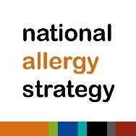
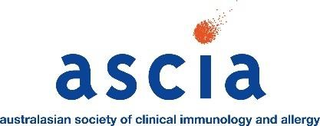

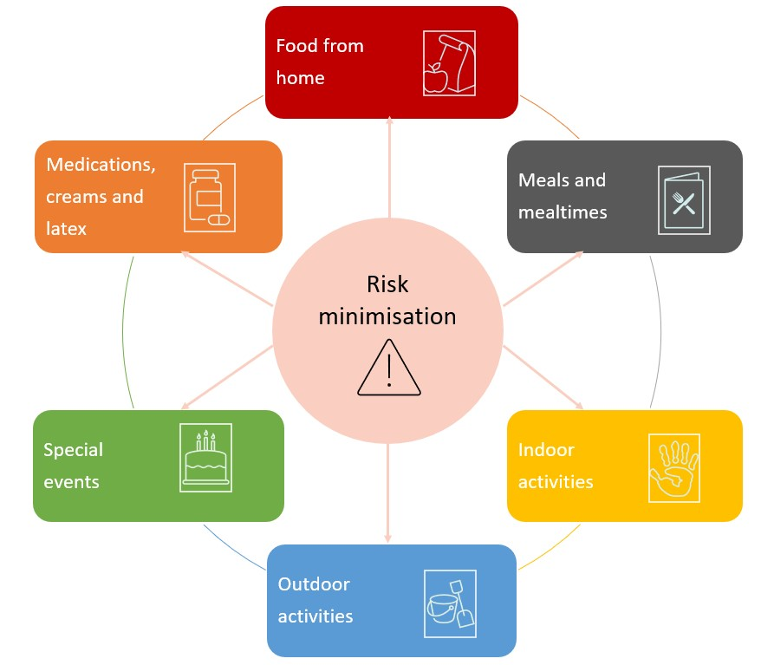

Food from home
- Snack/lunch boxes, water bottles, milk bottles, baby formula and special milks should be clearly labelled with the child's name.
- Request families do not send messy foods (such as grated cheese, nut spreads, yoghurt tubs) if there is a child with allergies to those foods who is enrolled at the service.
- If a child has multiple or complex food allergies it may be decided that the child will only eat food brought from home. This should be discussed with the parent/guardian when the child is enrolled.
- Food restrictions (not food bans) of some foods may have a role to play in very young children. This may be needed where common toys are handled and put into the mouth, due to the increased likelihood of food being left on toys. A food restriction should only be one of many strategies aimed at minimising risk of exposure.

Meals and mealtime supervision
- In cases where children are very young (infants, toddlers) CEC services may choose to have allergen restricted spaces for children with food allergies to eat, for example, with no egg or cow’s milk (dairy). If this is implemented, children with food allergy should still be able to sit with their peers.
- CEC services may choose to exclude foods containing peanuts and tree nuts (such as cashew, hazelnut and almond) in their menu as these are not essential (core) foods and can be eaten at home. Foods which are core foods in the diet such as wheat, cow's milk (dairy) and egg cannot be removed in CEC services.
- Discuss menu options and products available with parents/guardians of children with food allergy.
- For children with multiple food allergies, it may be necessary to have food and drinks for the child that are checked by parents/guardians. Alternatively, the parents/guardians can provide some or all of the food for their child.
- It is suggested that all staff preparing and serving food to children undertake All about Allergens for CEC online training so they understand how to avoid cross contamination during storing, handling, preparing and serving food.
- Prepare food for children with food allergy first so their food does not come into contact with other foods being prepared. If the food is to be stored before it is given to the child, it must be clearly labelled with the child’s name and placed in an enclosed container or covered to avoid any contact with other food being stored.
- Use easily identified plates, bowls, cups, bottles, cutlery and utensils, using colour and/or a sticker, as well as the child's name. This means staff and children with food allergy can easily identify their food and drink.
- Thorough washing of kitchen equipment with hot, soapy water is needed to remove food allergens.
  - When preparing food, clean/separate utensils should be used.
  - If shared utensils are used, they should be washed in hot soapy water or the dishwasher to remove traces of potential allergens.
- Foods with precautionary allergen labelling statements (such as "may contain traces of…") should not be provided to children allergic to specific foods. They can still be given to other children at the CEC service who do not have those specific food allergies.
- Staff supervision is essential at meal and snack times. Where possible, have two staff members check that children with food allergy are given the right food.
  - If used, have a separate highchair for children with food allergy where possible. This highchair needs to be thoroughly cleaned between children as different children may be allergic to different foods.
  - Ensure that children do not have access to toys while they are eating.
- All children should wash their hands before eating.
  - Baby wipes can be used to remove allergens from hands (and faces) if running water and soap is not available.
  - Hand sanitiser should not be used as a substitute to washing hands with soap and water as it does not remove allergens.
- Children should always be seated to eat and drink, including babies and toddlers with milk bottles or drinking cups.
  - Holding babies while they drink their milk can prevent spills.
  - Using cups with lids will reduce the risk of spills.
  - Be careful when serving milk (dairy) products that tend to splatter. Foods such as yoghurt tubs and pouches can be avoided to reduce the risk of milk being splattered on surfaces such as tables and chairs.
- Children with food allergy should not share, or eat from each other’s plates, bowls, cups, bottles or cutlery.
  - If using shared platters (such as fruit), give children with food allergy their own separate platter or plate to serve themselves from.
- Supervision of children eating is essential, particularly for children with food allergies. However, children who have food allergies should not be isolated from their peers.
- Cleaning:
  - Thoroughly wipe down surfaces of tables, chairs and highchairs, with hot soapy water after meals.
  - Clean up food and drink spills immediately.
  - Clean up posits/vomit quickly and thoroughly as they can contain food allergens.
  - Use disposable paper towels where possible. If cloths are used, machine wash cloths before using again.

Indoor activities
- Young children often put their fingers in their mouth, eyes or up their nose, so minimising exposure to food allergens during everyday activities (not just mealtimes) is important.
- Games and activities should not involve the use of any foods that children are allergic to.
- Cooking activities can present a risk to children with food allergy as common allergens such as milk, egg, wheat are often ingredients.
- When cooking or doing activities containing food, talk to parents/guardians well in advance. Where possible known allergens should be substituted with suitable ingredients - parents/guardians of children with food allergy can provide advice.
- Wash toys and equipment regularly with hot soapy water. Wind toys and instruments (such as whistles, recorders) are high risk and are best avoided in CEC settings.
- Avoid using recycled craft items that could contain food allergens (such as empty plastic milk bottles, egg cartons, cereal boxes, empty peanut and tree nut butter jars, ice cream containers).
- Activities such as face painting or mask making (when moulded on the face of the child), should be discussed with parents/guardians prior to the activity, as products used may contain food allergens such as peanut, tree nut, wheat, milk or egg.
- Some materials (such as play dough) can contain food allergens.
  - Discuss options with parents/guardians of children with wheat allergy (such as using wheat-free flour).
  - Check that nut oils have not been used in the manufacturing process.
  - If a child with food allergy is unable to use the play dough, provide an alternative material for the child to use and ensure adequate supervision to avoid cross contamination.

Outdoor activities

Insect allergy
- Ensure children with insect allergy wear shoes when outside.
- Have bee and wasp nests removed by a professional.
- Consider poisoning of ant nests if there are children with ant allergy attending (this should only be done when children are not at the centre).
- Cover outdoor bins as they attract insects.
- Be aware of bees around water and in grassed or garden areas.
- Keep lawns and clover mowed.
- When purchasing plants, consider those less likely to attract bees and wasps (such as non-flowering plants).
- Specify play areas that are lower risk - away from garden beds, flowering plants, water, or garbage storage areas.
- Do not have open drink containers outside, particularly those containing sweet drinks, as they may attract stinging insects.

Tick allergy
- To reduce the risk of tick bites in tick prone regions, children should wear a hat and cover skin when outdoors and remove these before going indoors, where possible.
- They should tuck their pants into their socks and wear long sleeved tops if possible.
- Consider having an ether containing spray in the first aid kit when engaging in activities in areas where ticks may be present.

Animal allergy
- Some animal feed contains food allergens (such as nuts in birdseed and cow feed, milk and egg in dog food, fish in fish food, peanut butter in dog food, fish in cat food). If possible, source animal feed that does not contain foods that children are allergic to.
- Children with egg allergy should only handle chicks that hatched the previous day or longer (no wet feathers) and must wash their hands afterwards. Further information is available from Allergy & Anaphylaxis Australia.
- Exposure to animals such as domestic dogs, cats, rabbits, rats, mice, guinea pigs and horses may trigger contact dermatitis (rashes), eczema, allergic rhinitis (hay fever) and sometimes asthma.
- Anaphylaxis to animals such as horses or dogs is rare but may occur and should be considered with activities such as “show and tell”, or visits to farms or zoos.

Food allergy
- Do not use sunscreen containing any food products (such as nut oils, cow’s or goat’s milk).
- Children may be allergic to foods grown in the garden (it is possible to be allergic to any food including fruits and vegetables). Talk to parents/guardians if new foods are being introduced.
- Mulches used for gardens can contain food allergens (such as peanut shells) and mould allergens. If possible, source mulches that do not contain allergens and store in a dry place to minimise the growth of moulds.

Special events
- Children should not miss out on activities because of their food allergy, however they (or the CEC service as a whole) may have to do things slightly differently to increase safety.
- Special events such as picnics are high risk for children with food allergy as staff can be distracted. Speak with parents/guardians of children with food allergy to see if they (or a trusted relative) may be able to attend as a volunteer to supervise the child.
- Consider children with food allergy when planning any fundraisers, cultural days or stalls, breakfast mornings, picnics and other celebrations involving food.
- Liaise with the parents/guardians of children with food allergies well in advance so they can provide suitable food, adjust the activity to accommodate the children with food allergies and/or plan to help on the day.
- Send a notice home to all parents/guardians prior to the event outlining that one or more children at the service have food allergies and request that these foods are avoided where possible.
- Children with food allergy should not consume any food brought in by other children/families even if they are thought to be safe.
- Children with food allergy can participate in birthday celebrations if their parents/guardians supply a safe ‘treat box’ or safe cupcakes that are stored in the service freezer in a labelled sealed container, to prevent cross contamination.

Medications, creams and latex
- Any medication administered in the CEC service should be given in accordance with service guidelines, policy and procedures, and with the written permission of parents/guardians.
- Some soaps, nappy creams and moisturisers contain allergens.
  - Encourage parents/guardians of children with food allergy to supply their own skin treatments or ask them to check the ingredients of CEC service supplies.
  - Staff do not have to restrict creams and/or makeup they put on at home.
- Do not use sunscreen containing food products (such as nut oils, cow’s or goat’s milk).
- Use non-latex gloves at nappy changing stations, in first aid kits and in kitchens.
- Food for children with latex allergy should be prepared with clean hands or non-latex gloves.
- Non-latex balloons should be used when there is a child with latex allergy.
- First aid kits should have non-latex sticking plasters and non-latex gloves available.

This information has been adapted from a table that was initially produced by Allergy & Anaphylaxis Australia (A&AA). To ensure consistency of information A&AA, ASCIA and the National Allergy Strategy endorse these anaphylaxis risk minimisation strategies.

Disclaimer
This document has been developed by A&AA, ASCIA and the National Allergy Strategy and has been peer reviewed by ASCIA members. It is based on expert opinion and the available published literature at the time of review. Information contained in this document is not intended to replace medical advice and any questions regarding a medical diagnosis or treatment should be directed to a medical practitioner.

The development of this document is not funded by any commercial sources and is not influenced by commercial organisations.

October 2021

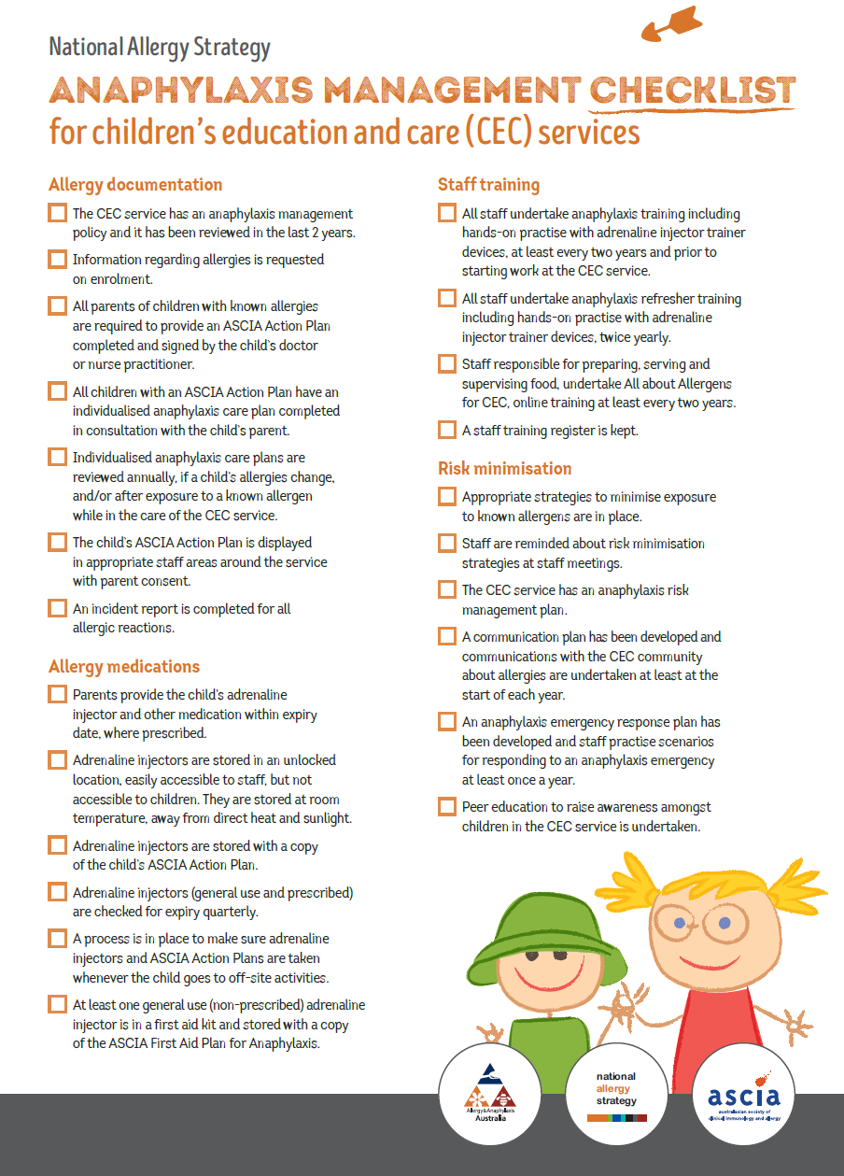
Attachment 2: Enrolment checklist for children diagnosed as at risk of anaphylaxis:

Attachment 3: Anaphylaxis risk minimisation plan template:
NAS Anaphylaxis risk management plan template for children’s education and care (CEC)

Applies to children and staff at risk of anaphylaxis.

Areas for risk management | Current status | Actions required
ANAPHYLAXIS MANAGEMENT POLICY
- Has the CEC service anaphylaxis management policy been reviewed within the last two years?  - Date of last review: | ☒ Yes ☐ No | Reviewed on the 10/10/2023
- Does the CEC service policy include:  - Identifying children at risk  - Allergy documentation  - Prescribed and general use adrenaline (epinephrine) injectors  - Staff training  - Risk management and risk minimisation  - Communication plan  - Peer education  - Emergency response plan  - Incident reporting | ☒ Yes ☐ No | Anaphylaxis Policy
RISK MINIMISATION
- Has the CEC service identified appropriate risk minimisation strategies to be implemented?  - Where is this information documented? | ☒ Yes ☐ No | Arrange meetings with parent/guardians of children with allergies to discuss and document risk minimisation strategies  In children’s files and info folder
- How are the risk minimisation strategies communicated to staff?  - When are staff informed of changes to risk minimisation strategies? |  | Staff meetings, staff have access to the individualised anaphylaxis care plans  As soon as they change
- Do you have appropriate risk minimisation strategies in place for children with known allergies during service operations (including indoor activities in the playground, excursions and when visitors attend the service)? | ☒ Yes ☐ No | Risk minimisation plans
EMERGENCY RESPONSE PLAN
- Do you have an anaphylaxis emergency response plan? | ☒ Yes ☐ No | Each child and staff have a communication plan.
- Does the emergency response plan:  - Follow the ASCIA First Aid Plan for Anaphylaxis?  - Include staff roles and responsibilities in an anaphylaxis emergency?  - Include the procedure for raising the alarm?  - Include the location and accessibility of adrenaline injectors (prescribed and general use)? | ☒ Yes ☐ No  ☒ Yes ☐ No  ☒ Yes ☐ No  ☒ Yes ☐ No
- Is the emergency response plan practised at least once a year? | ☒ Yes ☐ No | It is recommended that the emergency response plan is practised at least once a year
- Do you have an anaphylaxis emergency response plan for off-site activities? | ☒ Yes ☐ No | separate emergency response plans for any off-site activities
RISK MANAGEMENT FOR OFF-SITE ACTIVITIES
- Do you have a specific anaphylaxis risk management plan that needs to be completed for each activity outside of the service premises that includes:  - Food provision  - Policy regarding taking food/sharing food  - Medication management  - Communication strategy (staff and with families)  - Mobile phone connectivity and coverage  - Access to ambulance services/medical care  - Staff education and training  - Management of prescribed adrenaline injectors, including checks for expiry dates  - Number of general use adrenaline injectors  - Type of activities undertaken on the excursion  - Emergency response | ☐ Yes ☒ No  ☐ Yes ☒ No  ☒ Yes ☐ No  ☒ Yes ☐ No  ☒ Yes ☐ No  ☒ Yes ☐ No  ☒ Yes ☐ No  ☒ Yes ☐ No  ☒ Yes ☐ No  ☒ Yes ☐ No  ☒ Yes ☐ No
- Do you have a documented process for communicating with the excursion site about children’s allergies? | ☐ Yes ☐ No  ☒ N/A
- Do you encourage communication between parents and the excursion site caterers? | ☐ Yes ☐ No  ☒ N/A
COMMUNICATION PLAN
- Do you have a communication plan regarding anaphylaxis management? How does the CEC service communicate with:  - Staff (full time and part time)  - Casual and relief staff  - Volunteers  - Children (where appropriate)  - Parents of children with allergies  - The broader CEC community | ☒ Yes ☐ No  ☒ Yes ☐ No  ☒ Yes ☐ No  ☒ Yes ☐ No  ☒ Yes ☐ No  ☒ Yes ☐ No | Part of orientation induction  newsletters
ALLERGY DOCUMENTATION (IDENTIFYING CHILDREN AT RISK OF ANAPHYLAXIS)
- Type of allergies (food, insect, medication and latex) in each room? | ☒ Yes ☐ No | In the foyer and bathroom
- How many children have a red (anaphylaxis) or green (allergic reactions) ASCIA Action Plan in each year group? | ☐ Yes ☒ No | Need a list
- Do all children with known allergies have current red/green ASCIA Action Plans (reviewed and renewed by a doctor or nurse practitioner in the past 12-18 months)?  - Number with ASCIA Action Plan for Allergic Reactions (green)  - Number with ASCIA Action Plan for Anaphylaxis (red) | ☒ Yes ☐ No  Number:  Number: | e.g. Audit all ASCIA Action Plans
- Are individualised anaphylaxis care plans completed at the start of each year or when the CEC service is informed about the child’s allergy?  - Do all children with known allergies have an individualised anaphylaxis care plan completed in consultation with the parents?  - Are they signed off by the child’s parent?  - Is a copy of the child’s ASCIA Action Plan attached to the individualised anaphylaxis care plan? | ☒ Yes ☐ No  ☒ Yes ☐ No  ☒ Yes ☐ No  ☒ Yes ☐ No | e.g. Complete individualised anaphylaxis care plan on enrolment with parents/guardians  See Individualised anaphylaxis care plan template for CEC
- Do staff have access to the individualised anaphylaxis care plans? | ☒ Yes ☐ No | yes
PRESCRIBED AND GENERAL USE ADRENALINE INJECTORS
- Do all children with an ASCIA Action Plan for Anaphylaxis (red) have an adrenaline injector easily accessible to staff? | ☒ Yes ☐ No | See ASCIA Action Plan FAQ
- Do all children have an ASCIA Action Plan stored with their prescribed adrenaline injector? | ☒ Yes ☐ No
- Do all staff know where prescribed adrenaline injectors and individual ASCIA Action Plans are kept? | ☒ Yes ☐ No | e.g. Incorporated into the emergency response plan and staff communications
Outside school hours care:  - Are older children (e.g. children in before and after school care) allowed to carry their own adrenaline injector device?  - If so, do you stipulate that they must have a copy of their ASCIA Action Plan with the device?  - Do you have a process for checking they have their device with them? | ☐ Yes ☐ No ☒ N/A  ☐ Yes ☐ No ☒ N/A  ☐ Yes ☐ No ☒ N/A
- Do you have a process for checking expiry dates of prescribed adrenaline injectors? | ☒ Yes ☐ No | e.g. Adrenaline injectors are checked quarterly and parents are notified if the device is due to expire  see ASCIA adrenaline injector storage, expiry and disposal
- Do you have a process for documenting when staff take the prescribed adrenaline injectors off-site and when they are returned? | ☐ Yes ☒ No | e.g. Develop a register to sign adrenaline injectors in and out
- If prescribed adrenaline injector devices are provided to the CEC service, is there a process for parents signing them in and out (e.g. taken home over the holidays)? | ☐ Yes ☒ No | e.g. Develop a register to sign adrenaline injectors in and out
- Does the CEC service have at least one general use adrenaline injector?  - Is the adrenaline injector the appropriate dose for the age of the children attending the CEC service? | ☒ Yes ☐ No  ☒ Yes ☐ No
- How has the number of general use adrenaline injectors been determined? | ☒ Yes ☐ No | We have one spare in case a child is in need of a second dose or in an emergency
- What brand of adrenaline injector is/are the general use injector/s? | ☒ EpiPen®  ☐ Anapen®
- Are general use adrenaline injectors stored with a copy of the ASCIA First Aid Plan for Anaphylaxis for that device?  - (i.e. an Anapen® First Aid Plan stored with an Anapen® device) | ☒ Yes ☐ No
- Are general use adrenaline injector device expiry dates checked quarterly? | ☒ Yes ☐ No
- Where are general use adrenaline injectors stored and why was this location chosen? |  | With all other medication
- Are staff informed about the location of the general use adrenaline injector/s? | ☒ Yes ☐ No
- Do all staff have easy access (unlocked location) to general use adrenaline injectors? | ☒ Yes ☐ No
- Are general use adrenaline injectors stored out of reach of young children and away from direct sunlight and heat? | ☒ Yes ☐ No | see ASCIA adrenaline injector storage, expiry and disposal
- Do you have a process for determining if the general use device(s) should be taken offsite?  - Where is this process documented? | ☐ Yes ☒ No
- When general use or prescribed adrenaline injectors are taken off-site, are they protected from direct sunlight and heat? | ☒ Yes ☐ No
STAFF TRAINING
- Have all staff (including casual and relief staff) completed anaphylaxis management training within the last two years? | ☒ Yes ☐ No | Not admin
- Is a staff training register kept? | ☒ Yes ☐ No | A staff training register includes the name of the staff member, the date they completed the training, the course they completed and the name of the training provider
- What training course are staff recommended to undertake? |  | Full First aid, anaphylaxis and asthma and yearly cpr
- Have staff undertaken anaphylaxis refresher training (including hands on practise with adrenaline injector trainer devices) in the last 6 months? | ☒ Yes ☐ No | Every 3 months
- Is anaphylaxis refresher training documented in the training register? | ☒ Yes ☐ No
- Where are the adrenaline injector trainer devices for staff to practise with, stored?  - Are they stored separate to the real adrenaline injector devices containing adrenaline and labelled ‘Trainer device only’? | ☒ Yes ☐ No | Located in the kitchen
- Have any CEC staff expressed concerns about their ability to respond appropriately to an anaphylaxis emergency including willingness to administer an adrenaline injector?  - If yes, what measures are in place to reduce this risk? | ☐ Yes ☒ No
- Have all staff responsible for preparing and serving food (e.g. cooks, chefs, educators) completed the National Allergy Strategy All about Allergens for CEC online training in the last two years? | ☐ Yes ☒ No | All about Allergens for CEC online training is recommended
- Is food allergen management training documented in the staff training register? | ☒ Yes ☐ No
COMMUNITY AND PEER EDUCATION
- How do you communicate with the CEC community about food allergy and anaphylaxis? |  | newsletters and our app
- Do you support children with food allergies through peer education?  - How is this coordinated?  - When does this happen? | ☒ Yes ☐ No | e.g. Communication with the school community - See Sample letter to parents  e.g. Peer education using Allergy & Anaphylaxis Australia curriculum resources
POST INCIDENT MANAGEMENT AND INCIDENT REPORTING
- Do you have a post-incident process in place that includes:  - Replacement of used adrenaline injectors as soon as possible?  - Development of an interim plan while waiting for replacement of used adrenaline injector?  - Debriefing session to identify if additional risk minimisation strategies are required and review of individualised anaphylaxis care plan?  - Review of emergency response plan?  - Access to post-incident counselling services for staff and children? | ☐ Yes ☒ No  ☐ Yes ☒ No  ☒ Yes ☐ No  ☒ Yes ☐ No  ☐ Yes ☐ No | e.g. Include links to reporting requirements/support resources  DET.VIC
- Who is responsible for reporting anaphylaxis incidents? | Nominated supervisor | An Anaphylaxis incident reporting template (CEC) is available

Date of completion:9/08/2022
Name and signature of staff completing this Anaphylaxis risk management plan: Rita, Charlotte, Steph, Nicole, Angela
Date of next review:9/08/2023

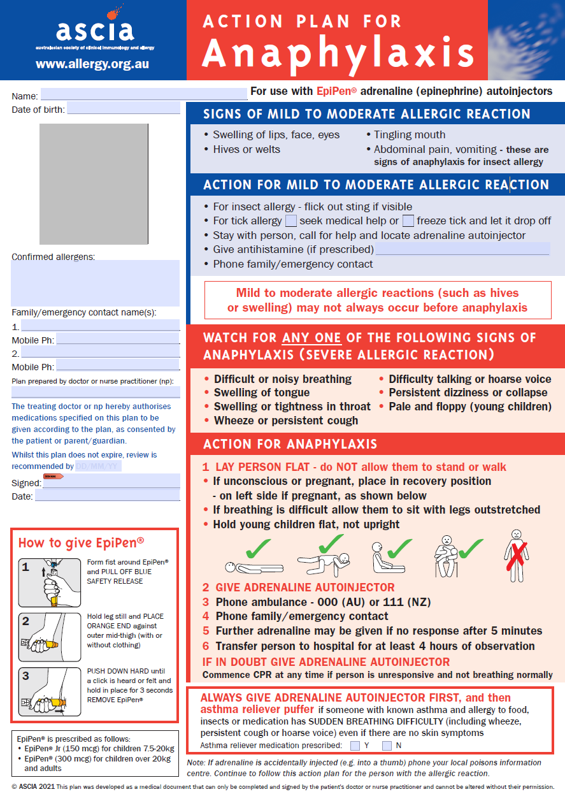
Attachment 4: First Aid Treatment for Anaphylaxis
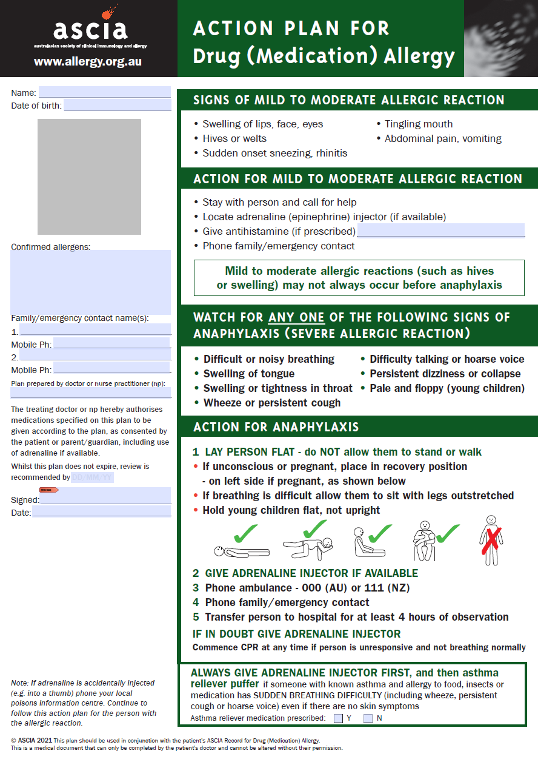

Attachment 5: Individualised anaphylaxis care plan template:
Individualised anaphylaxis care plan template for CEC
SECTION A – Child details – This section is to be completed by parent/guardian
Name: |  | Gender: | Date of birth:
Address: |  | Room:
 |  | Nominated supervisor:
Parent/guardian contact details |  | Medical contact details
Name:  Relationship to child:  Phone: |  | Doctor:  Medical Centre/Practice name:  Phone:
Name:
Relationship to child:
Phone:
SECTION B – Child health care planning – This section is to be completed by parent/guardian
Please tick what your child is allergic to below:
☐ Milk (dairy) | Tree nuts (please specify specific nut/s)  ☐ Almond  ☐ Brazil nut  ☐ Cashew  ☐ Hazelnut  ☐ Macadamia  ☐ Pecan  ☐ Pine nut  ☐ Pistachio  ☐ Walnut  ☐ All tree nuts should be avoided while at the CEC service
☐ Peanut
☐ Egg
☐ Soy
☐ Wheat
☐ Crustaceans (Shellfish)
☐ Molluscs
☐ Fish
☐ Sesame
☐ Lupin
☐ Other foods (please specify):

☐ Insect stings or bites (please specify if known):
☐ Medication (please specify if known):
☐ Latex
☐ Other/Unknown (please specify if known):

Name: CEC service: DOB:
SECTION C – Daily management – This section is to be completed in consultation with parent/guardian
List strategies that would minimise the risk of exposure to known allergens
(expand section as required if not completed electronically)

section D – Medication – This section is to be completed by parent/guardian
 | Medication 1 |  | Medication 2 | Medication 3
Name of medication
(include adrenaline injectors)
Expiry date
Where is the medication stored?  Note: Adrenaline injectors must be stored in an unlocked location at room temperature  (please tick all that are appropriate) | ☐ Stored at CEC service  Where:  ☐ Kept and managed  by self (if OSHC)  Where:  ☐ Other: |  | ☐ Stored at CEC service  Where:  ☐ Kept and managed  by self (if OSHC)  Where:  ☐ Other: | ☐ Stored at CEC service  Where:  ☐ Kept and managed  by self (if OSHC)  Where:  ☐ Other:
section E – ASCIA Action Plan – This section is to be completed by parent/guardian
Date ASCIA Action Plan completed by doctor or nurse practitioner:
Date of next review:
A copy of the child’s ASCIA Action Plan completed by the child’s doctor or nurse practitioner must be attached to this document.
SECTION F – Agreement – This section is to be completed by the CEC nominated supervisor and parent/guardian
This agreement authorises CEC staff to follow the advice of the child’s parent/guardian as set out in this child’s individualised anaphylaxis care plan. It is valid for one year or until the parent/guardian advises the CEC service of a change in their child’s health care requirements.
CEC nominated supervisor name:  Signature:  Date: |  | Parent/guardian name:  Signature  Date:
Review date:

